# REAL-TIME COMMUNICATION SYSTEM POWERED BY AI FOR SPECIALLY ABLED

**TEAM ID** - **PNT2022TMID08592**

|  |  |  |
| --- | --- | --- |
| S.No. | TEAM MEMBERS | REGISTER NUMBER |
| 1 | PRAVEEN KUMAR S (TL) | 727619BCS031 |
| 2 | SAKTHI KAVIN K | 727619BCS013 |
| 3 | LOGESH KUMAR S | 727619BCS035 |
| 4 | SHIVAPRIYAN K | 727619BCS049 |

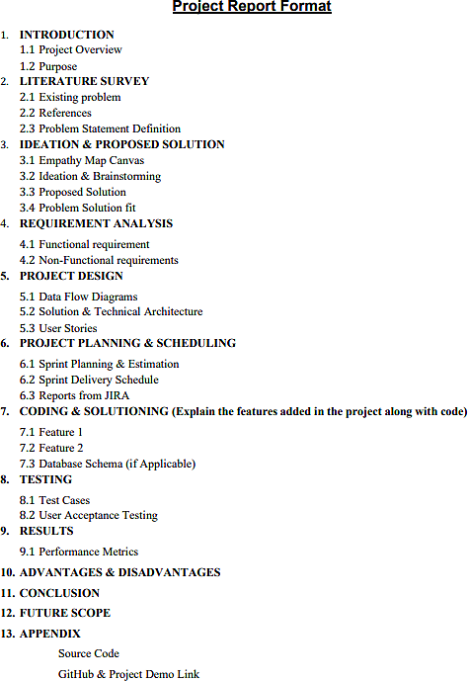

**CHAPTER 1 INTRODUCTION**

## Project Overview

In our society, we have people with disabilities. The technology is developing day by day but no significant developments are undertaken for the betterment of these people. Communications between deaf-mute and a normal person has always been a challenging task. It is very difficult for mute people to convey their message to normal people. Since normal people are not trained on hand sign language. In emergency times conveying their message is very difficult. The human hand has remained a popular choice to convey information in situations where other forms like speech cannot be used. Conversion System with Hand Gesture Recognition and translation will be very useful to have a proper conversation between a normal person and an impaired person in any language.

The project aims to develop a system that converts the sign language into a human hearing voice in the desired language to convey a message to normal people, as well as convert speech into understandable sign language for the deaf and dumb. We are making use of a convolution neural network to create a model that is trained on different hand gestures. An app is built which uses this model. This app enables deaf and dumb people to convey their information using signs which get converted to human-understandable language and image is given as output.

## PURPOSE

The proposed idea aims to develop a system that converts the sign language into a

human hearing voice in the desired language to convey a message to normal people, as

well as convert speech into understandable sign language for the deaf and dumb. We are

making use of a convolution neural network to create a model that is trained on different

hand gestures. An app is built which uses this model. This app enables deaf and dumb

people to convey their information using signs which get converted to human-

understandable language and speech is given as output.

# CHAPTER 2 LITERATURE SURVEY

## EXISTING PROBLEM

Some of the existing solutions for solving this problem are:

**Paper 1- Messaging and Video Calling Application for Specially Abled people**

**using Hand Gesture Recognition**

In the fifirst existing survey **R. R. Chhajed, K. P. Parmar, M. D. Pandya and N. G. Jaju, "Messaging and Video Calling Application for Specially Abled people using Hand Gesture Recognition," 2021 6th International Conference for Convergence in Technology (I2CT)*,* 2021, pp. 1-4, doi: 10.1109/I2CT51068.2021.9417924.**

**‘**The existing paper proposes a system to overcome these barriers and allow everyone to interact with each other irrespective of their disabilities and facilitate everyone to communicate with each other through messaging and video calling irrespective of their disabilities. This paper proposes a vision-based application which can be used for the communication of such people using text and video calling. For better accuracy various object detection and image classification algorithms are implemented. The application uses Indian Sign Language as the dataset.

**Paper 2 - IFSA: an integrated framework for developing IoT linked mobile**

**applications for specially abled people**

In the second existing survey **Kaur, S., Dhindsa, K.S. IFSA: an integrated framework for developing IoT linked mobile applications for specially abled people. *Wireless Netw* 28, 1375–1388 (2022)**

**The existing paper proposed** the Internet of Things has the potential to improve social interaction for visually challenged people. Hardware devices are constantly being equipped with various electronic sensors for collecting real-time data. However, specially-abled people need an integrated system to access the features of mobile applications and external hardware kits on one platform. Therefore, an integrated framework for the specially-abled is developed. IoT has the potential to improve social integration for people with visual defects. This research is an attempt to design a framework for developing a mobile application using IoT to provide secure and integrated services to the visually impaired people. The findings of the study revealed that the designed framework will help in developing various wireless embedded systems using mobile phones.

**Paper 3- Sign Language Recognition System for Deaf People**

In the third existing survey **Sharma, A., Pingale, S., Sabale, U., Patil, N., Dongre, S. (2023). Sign Language Recognition System for Deaf People. In: Garg, D., Kumar, N., Iqbal, R., Gupta, S. (eds) Innovations in Information and Communication Technologies. Algorithms for Intelligent Systems. Springer, Singapore.**

A sign language recognition system is a way to communicate with deaf–mute people. A large number of deaf and mute people are present across the world, and sometimes, it becomes difficult for normal people to communicate with them since not everyone can understand sign language. To establish effective communication between normal and specially abled people, there is a need to encourage the use of a sign language recognition system. In this language, people communicate through various hand gestures with each other. The purpose of language is to bridge the gap between the deaf–mute communities and the speaking folks. This research proposes an optimal recognition system whose major objective is to accomplish the translations of static sign language alphabets, numbers and words of American Sign Language into human and machine understandable English language. In the proposed model, in the first phase, the preprocessing functionality of input gestures takes place. In the next phase, various region properties of preprocessed gestures will be computed by the system. In the final phase, based on the propertiescalculated before, the translation of sign to text is to be carried out and the same works in the opposite manner as well for speech to sign conversion.

**Paper 4- A Robust Business Specific Real-Time Sign Language Translator**

In the fourth existing survey **Waiz KhanStudent, Department of Computer Engineering, Khaja Bandanawaz College of Engineering, Kalaburagi, Karnataka, India**

Communication is a great way of expressing yourself but not everyone is capable of communication. No, not everyone chooses to be silent, While some are born deaf and mute, others become one later in life due to certain conditions. The word “dumb” is quite offensive so I will address to someone who cannot speak as mute person throughout this paper. Returning to the topic this paper will enable a more effective way to fill the communication gap between deaf and mute person and normal person especially in places with crowd where special-abled person becomes nervous and anxious to make the business owner understand of his needs easily and are unable to express themselves. In order to remove this barrier and enable the effective communication between the special-abled buyer and the business owner, I have created our own data set of hand gestures and trained using Google Teachable Machine for common sentences that are exchanged between the buyer and seller***.***

**Paper 5- A Deep Learning Framework for Real-Time Indian Sign Language**

**Gesture Recognition and Translation to Text and Audio**

In the fifth existing survey **Deshpande, A.M., Inamdar, G., Kankaria, R., Katage,S. (2023). A Deep Learning Framework for Real-Time Indian Sign Language Gesture Recognition and Translation to Text and Audio. In: Pati, B., Panigrahi, C.R., Mohapatra, P., Li, KC. (eds) Proceedings of the 6th International Conference on Advance Computing and Intelligent Engineering. Lecture Notes in Networks and Systems, vol 428. Springer, Singapore.**

Indian Sign Language (ISL) is used in the deaf community all over India.Development of the ISL recognition system is an active area to aid this community. In ISL, most of the signs are two-handed signs, and thus, it differs from another commonly used American Sign Language (ASL) and seems complex. In this paper, the design and implementation of a system to recognize ISL signs is reported. Building such a system can help specially abled person/people, by providing a medium to communicate withothers without human interpreters. The proposed system is built using a deep convolutional neural network (CNN), which performs both feature extraction and classification, preceded by an image preprocessing step. A real-time input (live signs captured from webcam) is given to this system, and the output is delivered in the form of

text and audio

**Paper 6- Sign Language Recognition Using Convolutional Neural Network**

In the existing survey **Rakesh, S., Bharadhwaj, A., Sree Harsha, E. (2021). Sign Language Recognition Using Convolutional Neural Network. In: Raj, J.S., Iliyasu, A.M., Bestak, R., Baig, Z.A. (eds) Innovative Data Communication Technologies and Application. Lecture Notes on Data Engineering and Communications Technologies, vol 59. Springer, Singapore.**

In today’s world, communication is very important. A language is needed to communicate. Most of the specially abled people, use a different language for communication called sign language. This language helps them to communicate with other people with their hand expressions. These expressions will be different from country to country. In this paper, American sign language is used. This paper deals with helping specially abled people to communicate with people who don’t know sign language by using the approaches of computer vision and deep learning. Our paper uses convolutional neural network to solve this problem. The first part of our paper focuses on capturing different hand expressions in the form of video by the person and translating them to text using a convolutional neural network. The other part focuses on the reverse of it, showing GIF upon converting text. Integrating these two parts will help in two-way communication.

## Problem Statement Definition

The project aims to develop a system that converts the sign language into a human hearing voice in the desired language to convey a message to normal people, as well as convert speech into understandable sign language for the deaf and dumb. We are making use of a convolution neural network to create a model that is trained on different hand gestures. An app is built which uses this model. This app enables deaf and dumb people to convey their information using signs which get converted to human-understandable language and images are given as output.

Example:

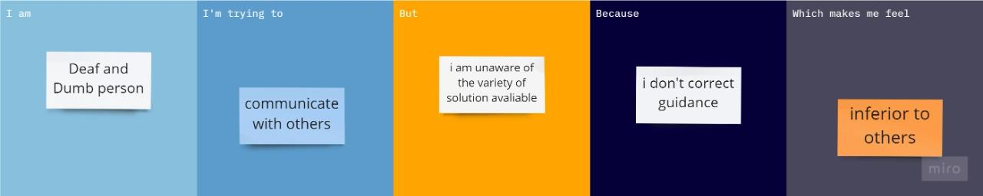

|  |  |  |  |  |  |
| --- | --- | --- | --- | --- | --- |
| **Problem**  **Statement (PS)** | **I am**  **(Customer)** | **I’m trying to** | **But** | **Because** | **Which makes me feel** |
| PS-1 | Deaf Person | Communicate with others | I am unaware of the variety of solution available | I do not have correct guidance | Inferior to others |
| PS-2 | Deaf and Dump Person | Convey my thoughts but peoples can’t my language | I am unaware about the technology development | I am unable to know the current updates | Stressed |

# CHAPTER 3

**IDEATION & PROPOSED SOLUTION**

## Empathy Map Canvas

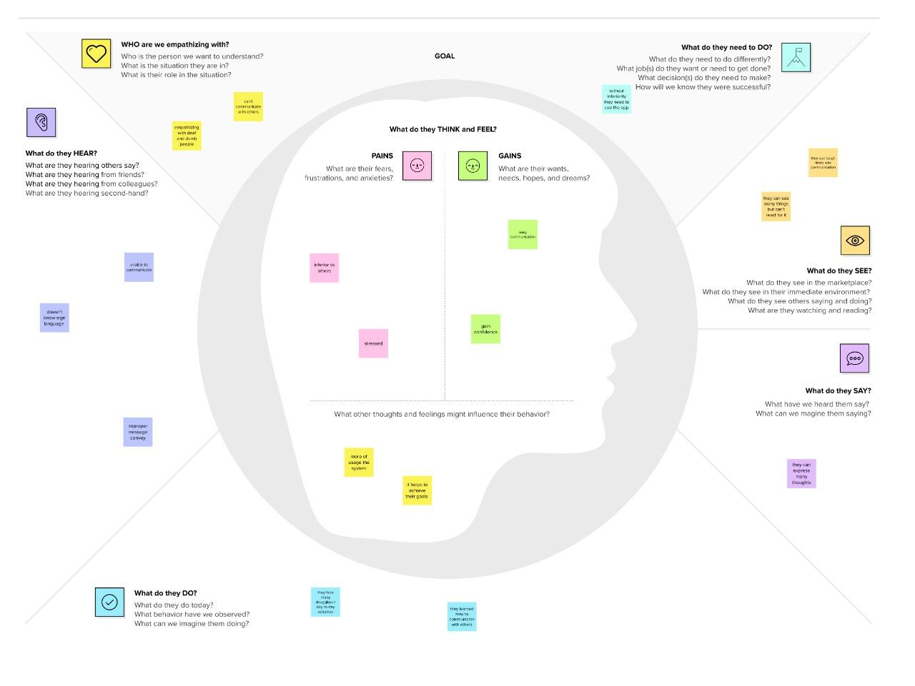

* 1. **Ideation & Brainstorming**

**Step-1: Team Gathering, Collaboration and Select the Problem Statement**

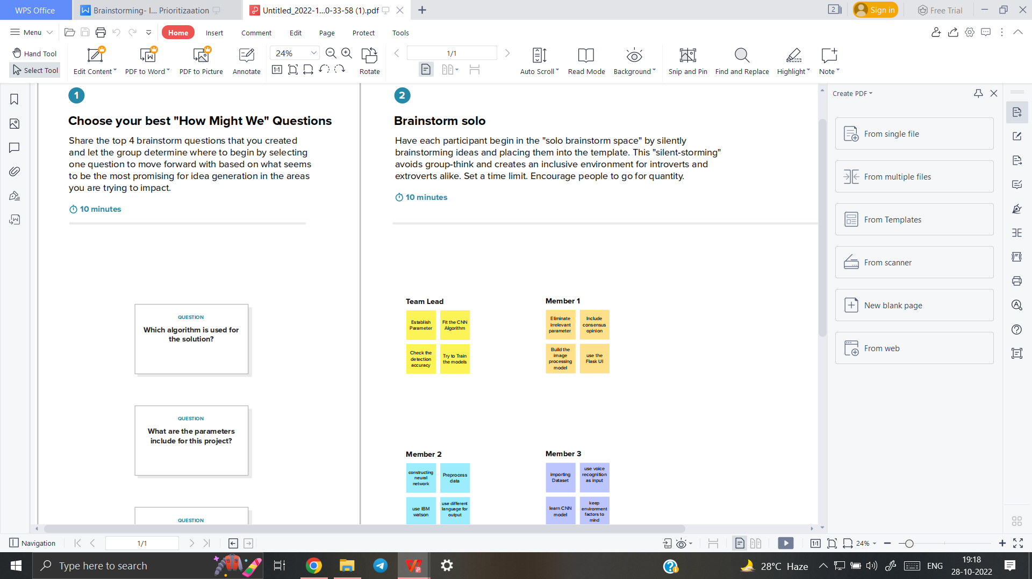

**Step-2: Brainstorm, Idea Listing and Grouping**



**Step-3: Idea Prioritization**

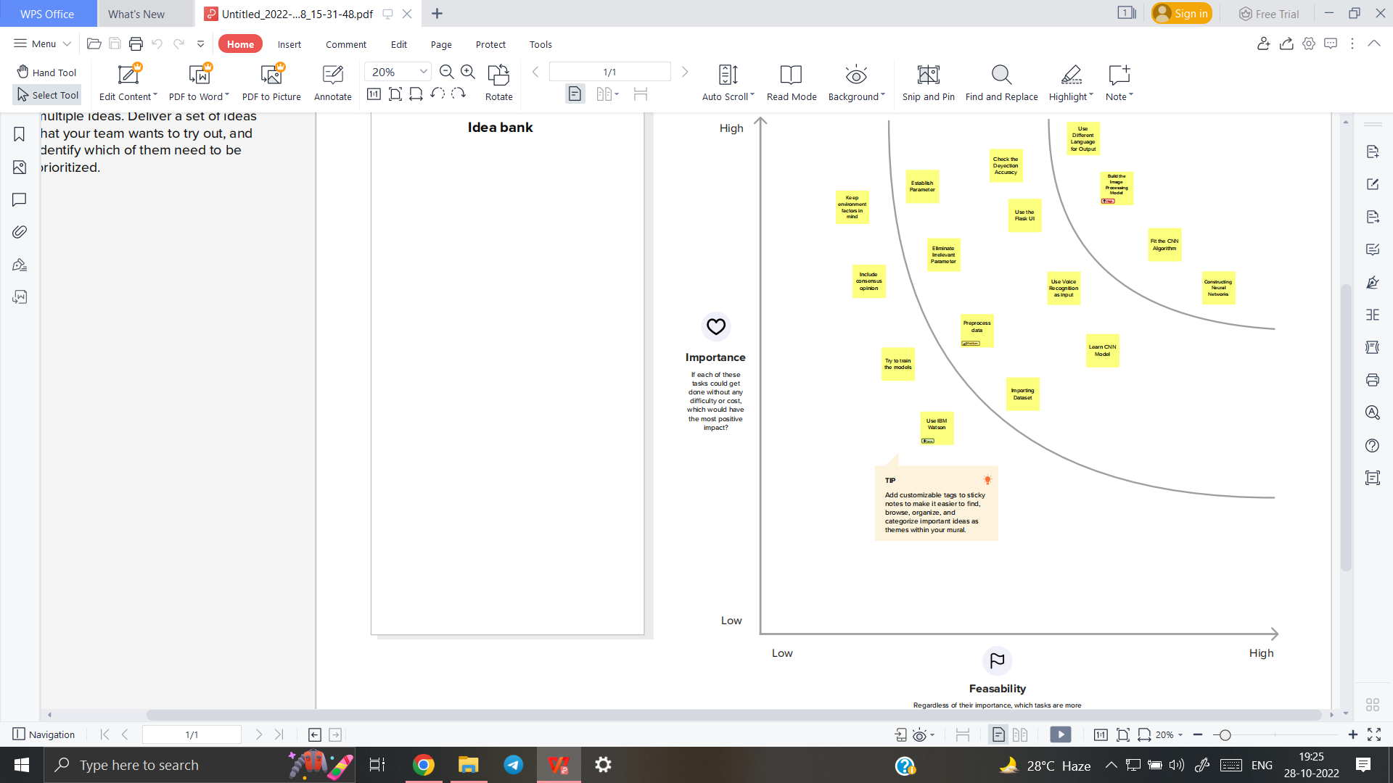

## Proposed Solution

|  |  |  |
| --- | --- | --- |
| **S.No.** | **Parameter** | **Description** |
|  | Problem Statement (Problem to be solved) | In our society, we have people with disabilities. The technology is developing day by day but no significant developments are undertaken for the betterment of these people. Communications between deaf-mute and a normal person has always been a challenging task. It is very difficult for mute people to convey their message to normal people. Since normal people are not trained on hand sign language. In emergency times conveying their message is very difficult. The human hand has remained a popular choice to convey information in situations where other forms like speech cannot be used. Voice Conversion System with Hand Gesture Recognition and translation will be very useful to have a proper conversation between a normal person and an impaired person in any language. |
|  | Idea / Solution description | The project aims to develop a system that converts the sign language into a human hearing voice in the desired language to convey a message to normal people, as well as convert speech into understandable sign language for the deaf and dumb. We are making use of a convolution neural network to create a model that is trained on different hand gestures. An app is built which uses this model. This app enables deaf and dumb people to convey their information using signs which get converted to human-understandable language and speech is given as output. |
|  | Novelty / Uniqueness | This processes the image of the person  who is using sign language and converts  it into the voice by analyzing the sign  used. |
|  | Social Impact / Customer Satisfaction | Differently abled people feel free  to communicate and it brings a  huge difference compared to the  past |
|  | Business Model (Revenue Model) | There are many people in the world who  are differently able,this application will  become more popular among them and it  will be installed by all and it will be  used,and so it will produce more money |
|  | Scalability of the Solution | Thus this would bring a new evolution in  Real Time Communication System  Powered by AI for Specially Able with  less time and safe enough resources. |

* 1. **Problem Solution fit**

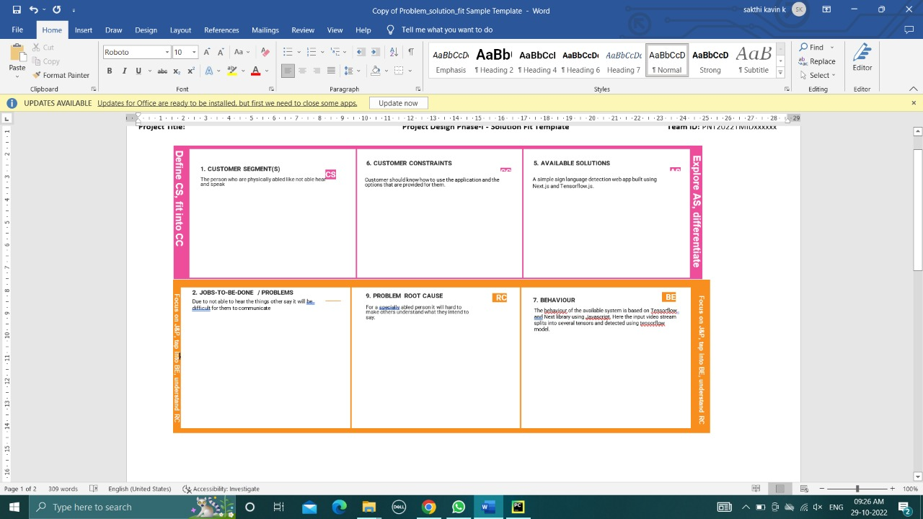

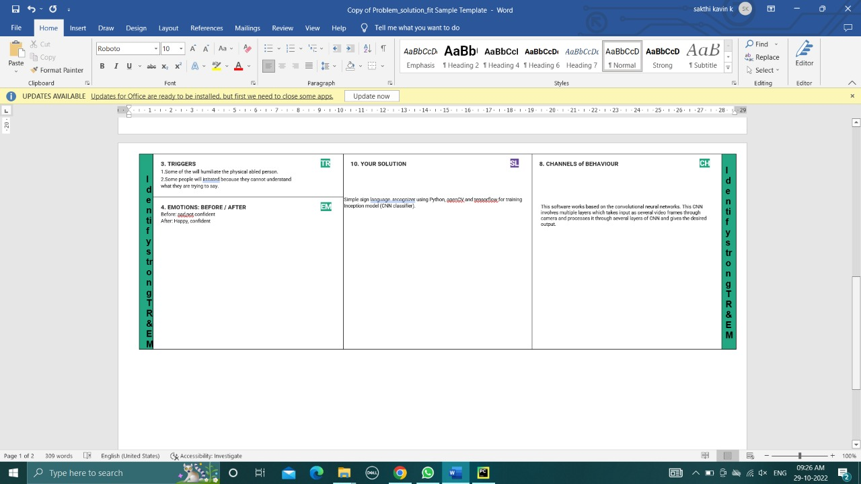

# CHAPTER 4 REQUIREMENT ANALYSIS

## 4.1 Functional requirements Hardware Requirements:

|  |  |
| --- | --- |
| Operating System | Windows, Mac, Linux |
| CPU (for training) | Multi Core Processors (i3 or above/equivalent) |
| GPU (for training) | NVIDIA AI Capable / Google's TPU |
| Web Cam | Integrated or External with Full HD Support |

**Software Requirements**

|  |  |
| --- | --- |
| Python | v3.9.0 or Above |
| Python Packages | flask, tensorflow, opencv-python, keras,  numpy,pandas, virtualenv, pillow |
| Web Browser | Mozilla Firefox, Google Chrome or any  modern web browser |
| IBM Cloud (for  training) | Watson Studio - Model Training & Deployment  as Machine Learning Instance |

# CHAPTER 5 PROJECT DESIGN

## Data Flow Diagrams

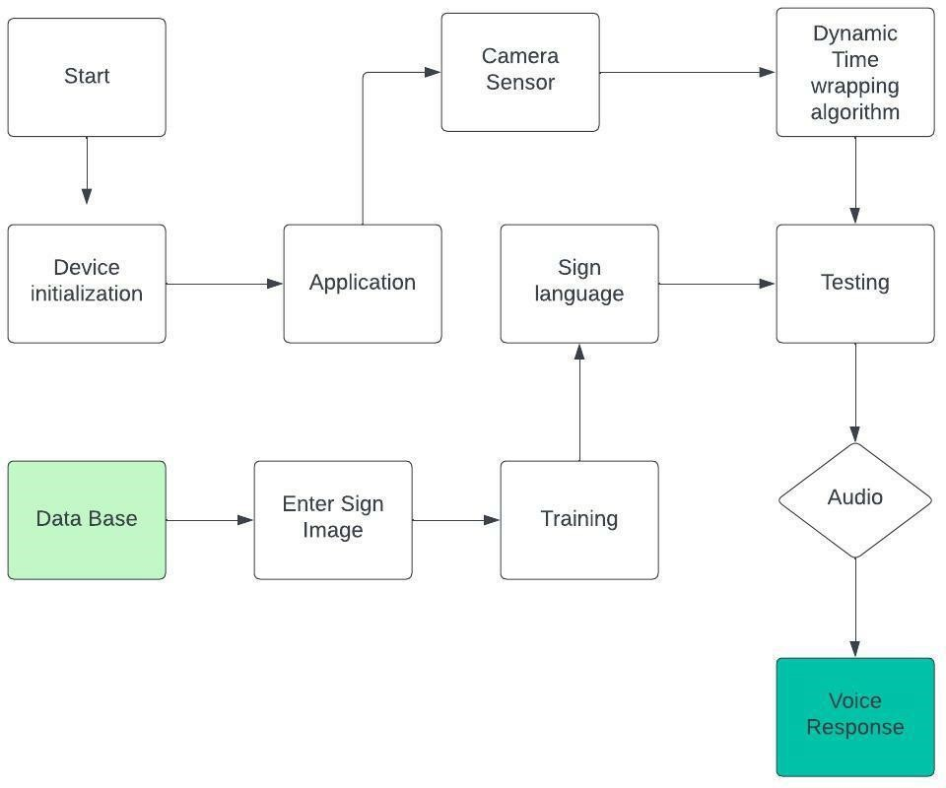

**Data Flow Diagram**

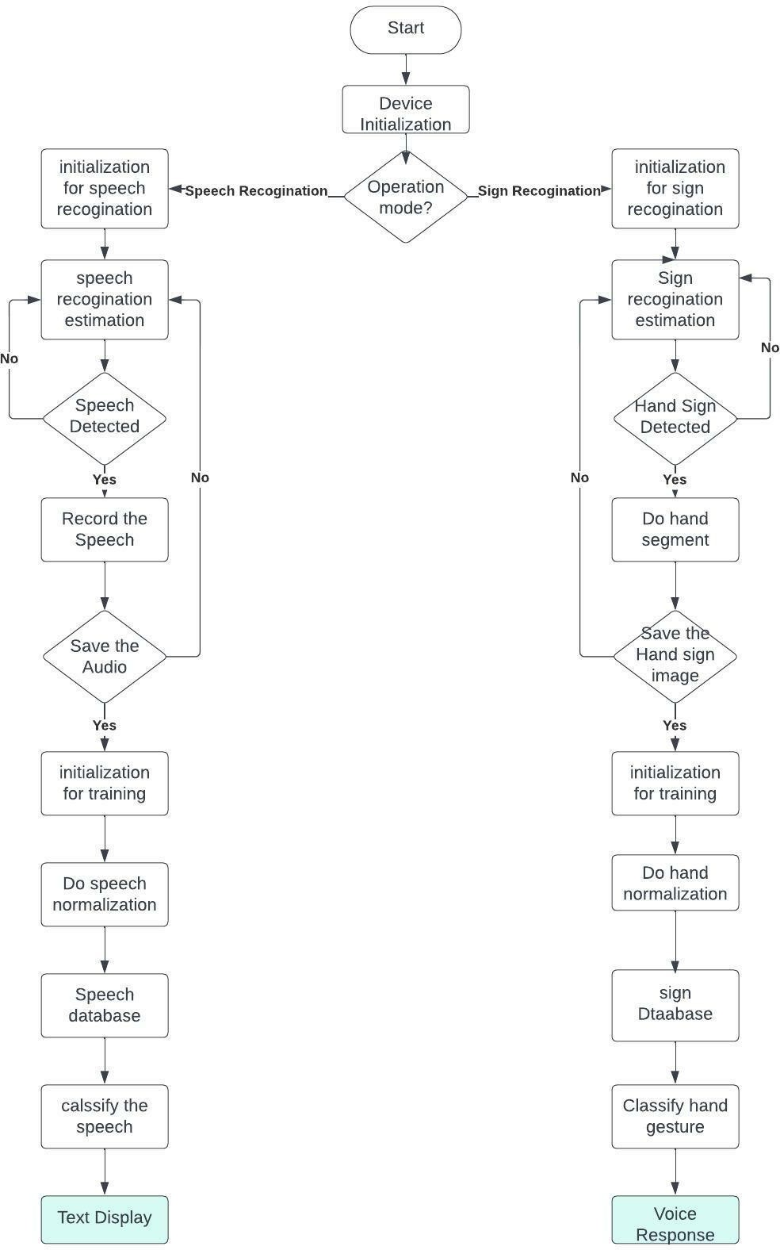

* 1. **Solution & Technical Architecture**

Solution Architecture:

Solution architecture is a complex process – with many sub-processes – that bridges the gap between business problems and technology solutions. Its goals are to:

* Find the best tech solution to solve existing business problems.
* Describe the structure, characteristics, behavior, and other aspects of the software to project stakeholders.
* Define features, development phases, and solution requirements.
* Provide specifications according to which the solution is defined, managed, and delivered.

.

## Example - Solution Architecture Diagram:

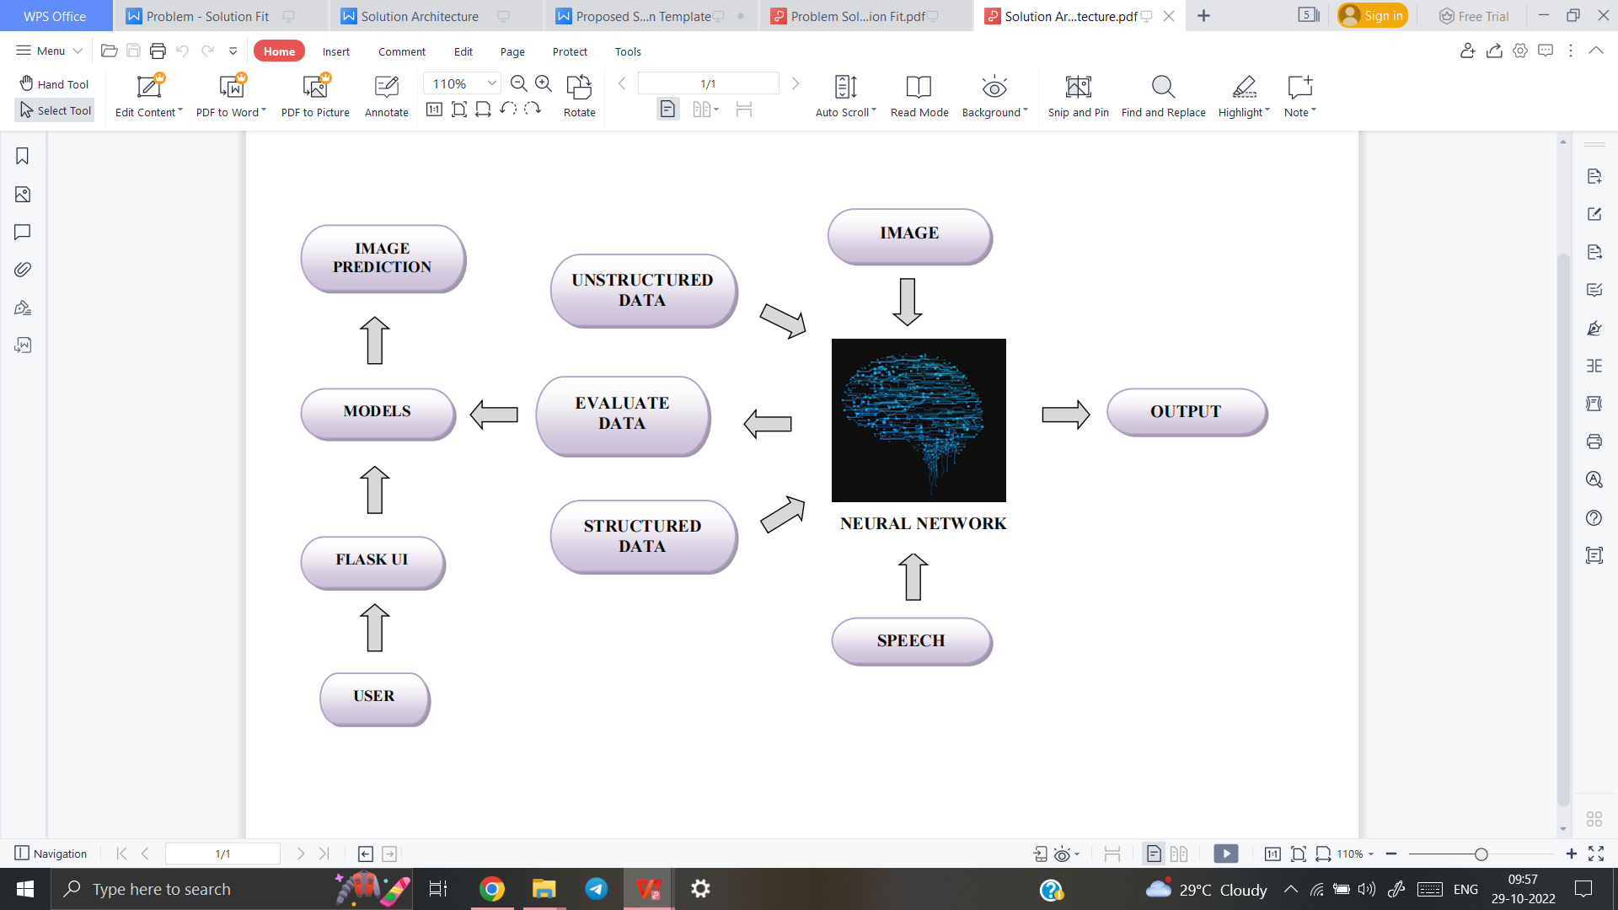

* 1. **User Stories**

|  |  |  |  |  |  |  |
| --- | --- | --- | --- | --- | --- | --- |
| **User Type** | **Functional Requirement (Epic)** | **User Story Number** | **User Story / Task** | **Acceptance criteria** | **Pri orit y** | **Release** |
| ***Customer***  *(Desktop user)* | Registration | USN-1 | As a user, I can register for the application by entering my email, password, and confirming my password. | I can access my account  / dashboard | High | Sprint-1 |
|  | **Login** | USN-2 | As a user, I will receive confirmation email once I have registered for the application | I can receive confirmation email & click confirm | High | Sprint-1 |
|  | **Dashboard** | USN-3 | As a user, I can select options in dashboard. | I can select options in dashboard. |  |  |
| ***Customer***  *(Desktop user)* | **Main page** | USN-4 | As a User, **I can enter the web page once clicked, which provides be the Guidelines** to use the app | I can **enter the web page** once clicked. | Med ium | Sprint-1 |
| *Customer (Desktop user)* | **Guidelines** | USN-5 | As a User, **I can give a read through the guidelines to understand the functioning of the app.** | I can **give a read through the guidelines.** | Med ium | Sprint-1 |
| ***Customer***  *(Desktop user)* | **Convert Sign** | USN-6 | As a User, **I can click the button Convert sign**, which directs me towards the Main screen | I can **click the button Convert sign and it direct me to main screen.** | Med ium | Sprint-2 |
| ***Customer***  *(Desktop user)* | **Camera (Hand movement detection)** | USN-7 | As a User, **I can show my hand sign towards the camera which converts them into text manner.** | **I can show my hand sign** towards the camera accurately. | Hig h | Sprint-2 |
| ***Customer***  *(Desktop user)* | **Voice mode** | USN-8 | Once the text is obtained, as a User **I can click on the voice mode which provides the text** | **I can click on the voice mode** which provides the text in | Hig h | Sprint-3 |
| ***Customer Care Executive*** | **Provide the necessary functionalitie s**  **required to use the app.** | USN-9 | As an Executive, I can **provide the Specifications of Camera required, and other factors** that are required for smooth functioning of the app. | **I can provide the Specifications** of camera required, and other factors | Lo w | Sprint-1 |
| ***Customer Care Executive*** | **Check the performanc e of the app** | USN-10 | As an Executive, I can **check the usage and queries obtained from the end users**. | I can **check the usage and queries** obtained from the end users. | Med ium | Sprint-1 |
| ***Administrator*** | **Receive**  **queries based on usage** | USN-11 | As an Admin, I can **take the queries from the customer care and perform the testing phase again, loading the other signs in the dataset**, in order to make the  customers to use the app effectively. | I can **take the queries from the customer care and perform necessary phases again.** | Hig h | Sprint-3 |

# CHAPTER 6

**PROJECT PLANNING AND SCHEDULING**

## Sprint Planning And Estimation

|  |  |  |  |
| --- | --- | --- | --- |
| **Milestone** | **Function (Epic)** | **Milestone Story Number** | **Story / Task** |
| **Milestone** 1 | Data collection | M1 | we're collecting dataset for building our project and creating two folders, one for training and another one for testing. |
| **Milestone 2** | Image preprocessing | M2 | Importing image data generator libraries and applying image data generator functionality to train the test set. |
| **Milestone 3** | Model building | M3 | Importing the model building libraries, Initializing the model, Adding Convolution layers, Adding the Pooling layers, Adding the Flatten layers, Adding Dense layers, Compiling the model Fit and Save the model. |
| **Milestone 4** | Testing the model | M4 | Import the packages first. Then we save the model and Load the test image, preprocess it and predict it. |
| **Milestone 5** | Application layer | M5 | Build the flask application and the HTML pages. |
| **Milestone 6** | Train CNN model | M6 | Register for IBM Cloud and train Image Classification Model. |
| **Milestone 7** | Final result | M7 | To ensure all the activities and resulting the final output. |

**MILESTONE ACTIVITYPLAN**

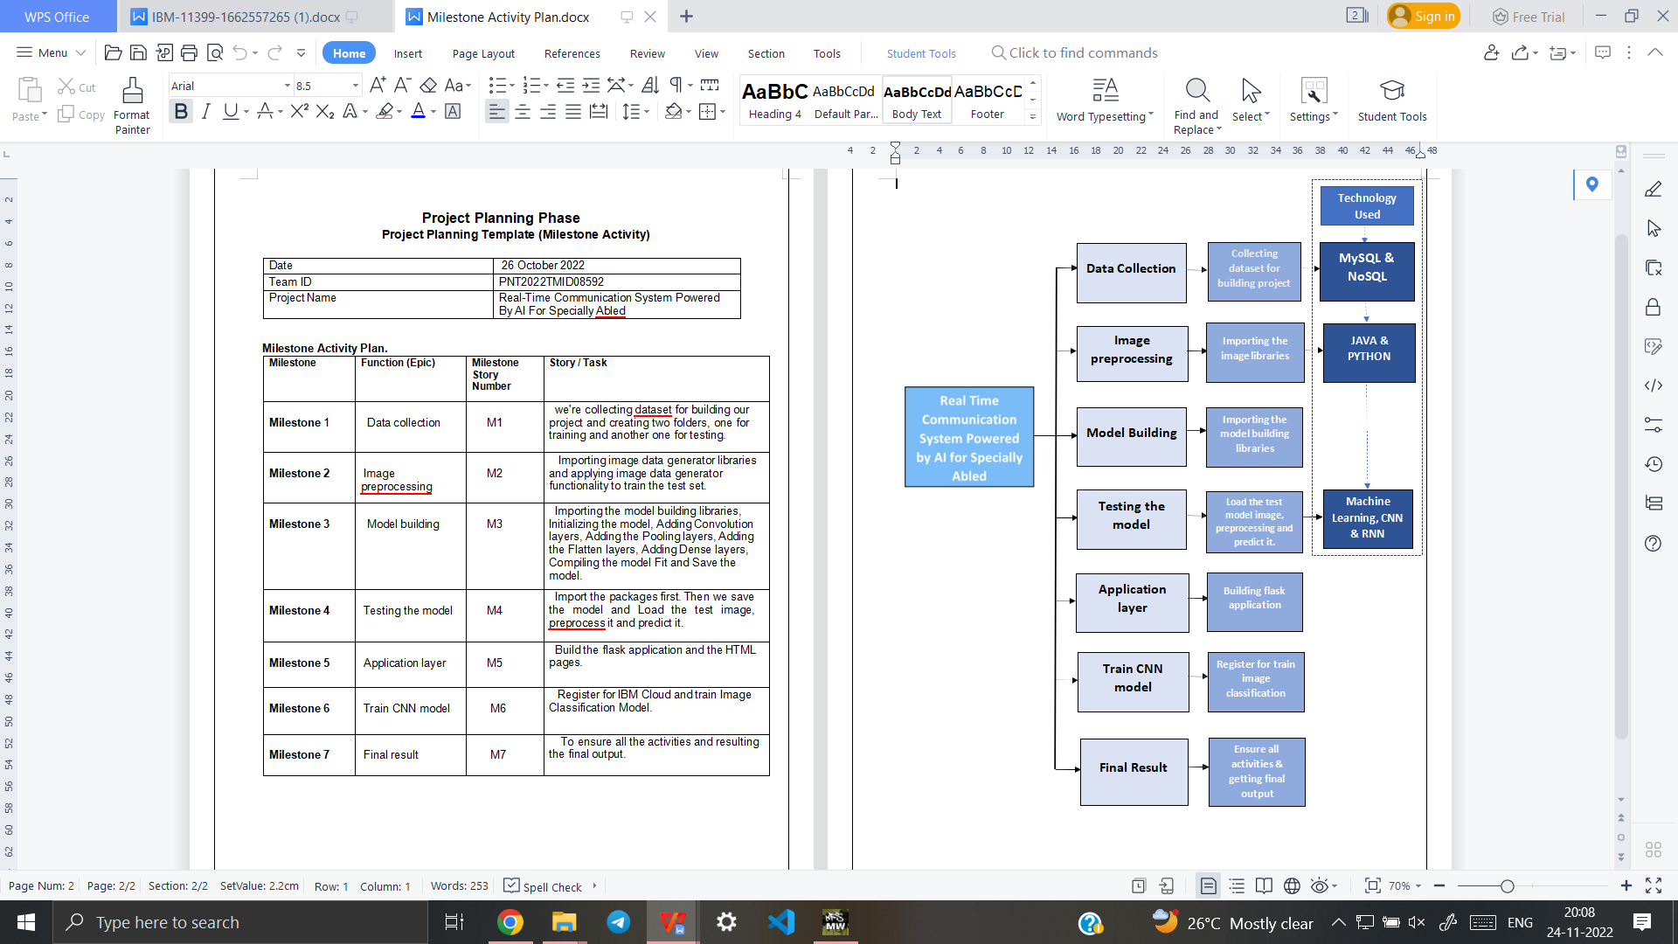

## SPRINT PLANING

|  |  |  |  |  |  |
| --- | --- | --- | --- | --- | --- |
| **Sprint** | **Functional Requirement**  **(Epic)** | **User Story**  **Number** | **User Story/Task** | **Story Points** | **Priority** |
| Sprint – 1 | Dataset Collection | USN – 1 | Collect Dataset for building model | 9 | High |
| Sprint – 1 | Image Preprocessing | USN – 2 | Perform pre- processing techniques on thedataset | 8 | Medium |
| Sprint – 2 | Model Building | USN – 3 | Import the required  libraries, add the necessary layersand compile the  model | 10 | High |
| Sprint – 2 |  | USN – 4 | Training the image classiﬁcation modelusing CNN | 7 | Medium |
| Sprint – 3 | Training and Testing the Model | USN – 5 | Training the model and testing the  model’s  performance | 9 | High |
| Sprint – 4 | Application Developme nt | USN – 6 | Converting the  input gesture image into English Alphabets | 8 | Medium |

* 1. **Sprint Delivery Schedule**

|  |  |  |  |  |  |  |
| --- | --- | --- | --- | --- | --- | --- |
| **Sprint** | **Total**  **StoryPoin ts** | **Durati on** | **Sprint StartDate** | **Sprint End Date (Planned)** | **Story**  **Points Complet ed (as on Planned End Date)** | **Sprint Release**  **Date (Actual)** |
| Sprint  – 1 | 17 | 6 Days | 24 October,  2022 | 29 October,  2022 | 17 | 29 Oct 2022 |
| Sprint | 17 | 6 Days | 31 October, | 05 | 17 | 05 Nov 2022 |
| – 2 |  |  | 2022 | November, |  |  |
|  |  |  |  | 2022 |  |  |
| Sprint | 9 | 6 Days | 07 | 12 | 9 | 12 Nov 2022 |
| – 3 |  |  | November, | November, |  |  |
|  |  |  | 2022 | 2022 |  |  |
| Sprint | 5 | 6 Days | 14 | 19 | 8 | 19 Nov 2022 |
| – 4 |  |  | November, | November, |  |  |
|  |  |  | 2022 | 2022 |  |  |

## Velocity

**Average Velocity= Velocity**

## Sprint Duration

* + - Average Velocity → AV
    - Velocity → Points per sprint
    - Sprint Duration → Number of days per sprint 1. Sprint – 1: AV = 17÷6 = 2.83

2. Sprint – 2: AV = 17÷6 = 2.83 '

3. Sprint – 3: AV = 9÷6 = 1.5

4. Sprint – 4: AV = 5÷6 = 0.83

## Report From Jira

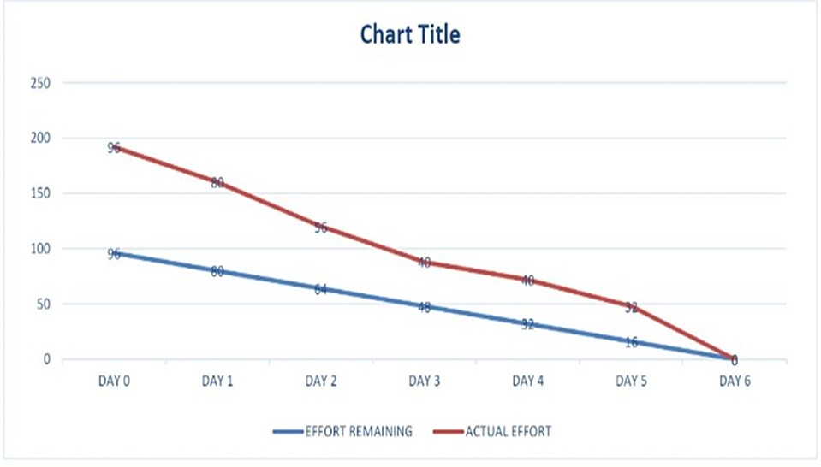

**BURNDOWN CHART**

# CHAPTER 7

**CODING AND EXECUTION**

# Feature 1

The proposed system consists of two features front end and backend. The frontend is designed using HTML and CSS. The first feature is a webpage whenever a user wants to translate the sign language to English, they can go to the webpage it has start button. On pressing the start button, it will turn on the camera for live translation. Once the camera is turned on, we can start translating.

# Coding:

<!DOCTYPE html>

<html lang="en">

<head>

<meta charset="utf-8">

<meta name="viewport" content="width=device-width, initial-scale=1.0, shrink-to-fit=no">

<title>REAL TIME COMM</title>

<link rel="stylesheet" href="https://cdn.jsdelivr.net/npm/bootstrap@5.1.3/dist/css/bootstrap.min.css">

<link rel="stylesheet" href="https://use.fontawesome.com/releases/v5.12.0/css/all.css">

<link rel="stylesheet" href="static/Navbar-Centered-Brand.css">

</head>

<body style="background: #6a6767;">

<nav class="navbar navbar-light navbar-expand-md py-3" style="background: #FC3D3D;">

<div class="container">

<div></div><a class="navbar-brand d-flex align-items-left" href="#"><span

class="bs-icon-sm bs-icon-rounded bs-icon-primary d-flex justify-content-left align-items-left me-2 bs-icon"><i

class="fas fa-flask"></i></span><h4 style="color: #030000; font-style: oblique; text-align: left;"><strong> Real-Time Communication

System Powered By AI&nbsp;For Specially Abled</strong></h4></a>

<div></div>

</div>

</nav>

<section>

<div class="d-flex flex-column justify-content-center align-items-center">

<div class="d-flex flex-column justify-content-center align-items-center" id="div-video-feed"

style="width: 800px;height: 600px;margin: 10px;min-height: 480px;min-width: 640px;border-radius: 50px;border: 10px groove #045816 ;">

<img src="{{ url_for('video') }}" style="width: 100%;height: 100%;color: rgb(255,255,255);text-align: center;font-size: 20px;"

alt="Camera Access Not Provided!">

</div>

</div>

<div class="d-flex flex-column justify-content-center align-items-center" style="margin-bottom: 20px;"><button

class="btn btn-info" type="button" data-bs-target="#modal-1" data-bs-toggle="modal"

style=" background: #FC3D3D";>Quick Reference

-<strong> ASL Alphabets</strong></button></div>

</section>

<section>

<div class="modal fade" role="dialog" tabindex="-1" id="modal-1">

<div class="modal-dialog" role="document">

<div class="modal-content">

<div class="modal-header">

<h4 class="modal-title">American Sign Language - Alphabets</h4><button type="button"

class="btn-close" data-bs-dismiss="modal" aria-label="Close"></button>

</div>

<div class="modal-body"><img src='ASL_Alphabet.jpg' height=100% width="450px"></div>

<div class="modal-footer"><button class="btn btn-secondary" type="button"

data-bs-dismiss="modal">Close</button></div>

</div>

</div>

</div>

</section>

<section>

<div class="container">

<div class="accordion text-white" role="tablist" id="accordion-1">

<div class="accordion-item" style="font-style: oblique; background: rgb(33,37,41);">

<h2 class="accordion-header" role="tab"><button class="accordion-button" data-bs-toggle="collapse"

data-bs-target="#accordion-1 .item-1" aria-expanded="true"

aria-controls="accordion-1 .item-1"

style="font-style:inherit; background: #FC3D3D;color: rgb(255,255,255);">About The Project</button></h2>

<div class="accordion-collapse collapse show item-1" role="tabpanel" data-bs-parent="#accordion-1">

<div class="accordion-body">

<p class="mb-0">In our society, we have people with disabilities. The technology is developing day by day but no significant developments are undertaken for the betterment of these people. Communications between deaf-mute and a normal person has always been a challenging task. It is very difficult for mute people to convey their message to normal people. Since normal people are not trained on hand sign language. In emergency times conveying their message is very difficult. The human hand has remained a popular choice to convey information in situations where other forms like speech cannot be used. Voice Conversion System with Hand Gesture Recognition and translation will be very useful to have a proper conversation between a normal person and an impaired person in any language..</p>

</div>

</div>

<div class="accordion-item" style="font-style: oblique; background: rgb(33,37,41);">

<h2 class="accordion-header" role="tab"><button class="accordion-button collapsed"

data-bs-toggle="collapse" data-bs-target="#accordion-1 .item-2" aria-expanded="false"

aria-controls="accordion-1 .item-2"

style="font-style: oblique; background: #FC3D3D;color: rgb(231,241,255);">Developed By</button></h2>

<div class="accordion-collapse collapse item-2" role="tabpanel" data-bs-parent="#accordion-1">

<div class="accordion-body">

<p class="mb-0">Students From Dr.MCET COLLEGE OF ENGINEERING AND TECHNOLOGY<br><br>TEAM ID-- <strong>PNT2022TMID08592</strong><br><br>1. <strong>PRAVEEN KUMAR S</strong> <br>2.

<strong>SAKTHI KAVIN K</strong> <br>3. <strong>LOGESH KUMAR S</strong><br>4. <strong>SHIVAPRIYAN K</strong>

</p>

</div>

</div>

</div>

</div>

</div>

</section>

<script src="https://cdn.jsdelivr.net/npm/bootstrap@5.1.3/dist/js/bootstrap.bundle.min.js"></script>

</body>

</html>

## Feature 2

The second feature of the proposed system is backend. The backend is designed using python with the packages of python like flask, tensorflow, opencv-python, keras, numpy, pandas, virtualenv, pillow and Machine learning technology and trained with datasets. Once the camera is turned on the system detects and identify the sign language and translate it to English by matching the live action with the trained dataset.

## Coding:

from flask import Flask, Response, render_template

from camera import Video

import cv2

from keras.models import load_model

from keras.preprocessing import image

import numpy as np

from cvzone.HandTrackingModule import HandDetector

from cvzone.ClassificationModule import Classifier

import math

app = Flask(__name__)

camera = cv2.VideoCapture(0)

detector = HandDetector(maxHands=1)

classifier = Classifier('E:/ibm project/prj10/keras_model.h5', 'E:/ibm project/prj10/labels.txt')

offset = 20

imgSize = 300

#folder = "Data/C"

counter = 0

labels = ["A", "B", "C"]

@app.route('/')

def index():

return render_template('index.html')

def gen():

while True:

success, img = camera.read()

imgOutput = img.copy()

hands, img = detector.findHands(img)

if hands:

hand = hands[0]

x, y, w, h = hand['bbox']

imgWhite = np.ones((imgSize, imgSize, 3), np.uint8) * 255

imgCrop = img[y - offset:y + h + offset, x - offset:x + w + offset]

imgCropShape = imgCrop.shape

aspectRatio = h / w

if aspectRatio > 1:

k = imgSize / h

wCal = math.ceil(k * w)

imgResize = cv2.resize(imgCrop, (wCal, imgSize))

imgResizeShape = imgResize.shape

wGap = math.ceil((imgSize - wCal) / 2)

imgWhite[:, wGap:wCal + wGap] = imgResize

prediction, index = classifier.getPrediction(imgWhite, draw=False)

print(prediction, index)

else:

k = imgSize / w

hCal = math.ceil(k * h)

imgResize = cv2.resize(imgCrop, (imgSize, hCal))

imgResizeShape = imgResize.shape

hGap = math.ceil((imgSize - hCal) / 2)

imgWhite[hGap:hCal + hGap, :] = imgResize

prediction, index = classifier.getPrediction(imgWhite, draw=False)

cv2.rectangle(imgOutput, (x - offset, y - offset - 50),

(x - offset + 90, y - offset - 50 + 50), (255, 0, 255), cv2.FILLED)

cv2.putText(imgOutput, labels[index], (x, y - 26), cv2.FONT_HERSHEY_COMPLEX, 1.7, (255, 255, 255), 2)

cv2.rectangle(imgOutput, (x - offset, y - offset),

(x + w + offset, y + h + offset), (255, 0, 255), 4)

# cv2.imshow("ImageCrop", imgCrop)

# cv2.imshow("ImageWhite", imgWhite)

# cv2.imshow("Image", imgOutput)

k = cv2.waitKey(1)

if k == ord('q'):

break

camera.release()

cv2.destroyAllWindows()

yield (b'--frame\r\n'

b'Content-Type: image/jpeg\r\n\r\n' + imgOutput + b'\r\n')

@app.route('/video')

def video():

# video = Video()

return Response(gen(), mimetype='multipart/x-mixed-replace; boundary=frame')

if __name__ == '__main__':

app.run()

## CHAPTER 8 TESTING

# Importing Libarries

from tensorflow.keras.models import load_model from tensorflow.keras.preprocessing import image import numpy as np

import cv2

# loading model

model = load_model('E:\ibm project\Real time communication system\Application Building\Build a Flask Application\realtime.h5')

from skimage.transform import resize def detect(frame):

img = resize(frame, (64, 64, 3))

img = np.expand_dims(img, axis = 0) if np.max(img) > 1:

img = img/255.0

prediction = model.predict(img) print(prediction)

return prediction

frame = cv2.imread(r"E:\ibm project\Real time communication system\Dataset\test_set\A\16.png")

data = detect(frame)

index = ['A','B','C','D','E','F','G','H','I']

index[np.argmax(data)] # Importing Libraries import cv2

import numpy as np

from tensorflow.keras.models import load_model from tensorflow.keras.preprocessing import image # Loading Model

model = load_model("E:\ibm project\Real time communication system\Application Building\Build a Flask Application\realtime.h5") video = cv2.VideoCapture(0)

index = ['A','B','C','D','E','F','G','H','I']

while True:

success, frame = video.read() cv2.imwrite('frame.jpg', frame)

img = image.load_img('frame.jpg', target_size = (64, 64)) x = image.img_to_array(img)

x = cv2.cvtColor(x, cv2.COLOR_BGR2HSV) a = x.array_to_img(x)

cv2.imshow("")

x = np.expand_dims(x, axis = 0)

pred = np.argmax(model.predict(x), axis = 1) y = pred[0]

copy = frame.copy()

cv2.rectangle(copy, (320, 100), (620, 400), (255, 0, 0), 5)

cv2.putText(frame, "The Predicted Alphabet : " + str(index[y]), (100, 100), cv2.FONT_HERSHEY_SIMPLEX, 1, (0, 0, 0), 4)

cv2.imshow('frame', frame)

if cv2.waitKey(1) & 0xFF == ord('q'): break

video.release() cv2.destroyAllWindows()

## CHAPTER 9 RESULT

* 1. **Performance Metrics**

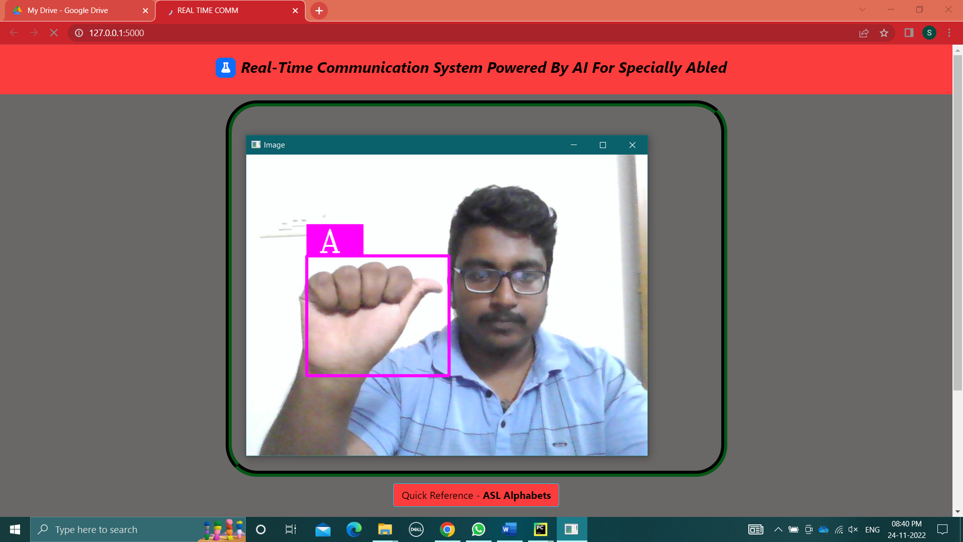

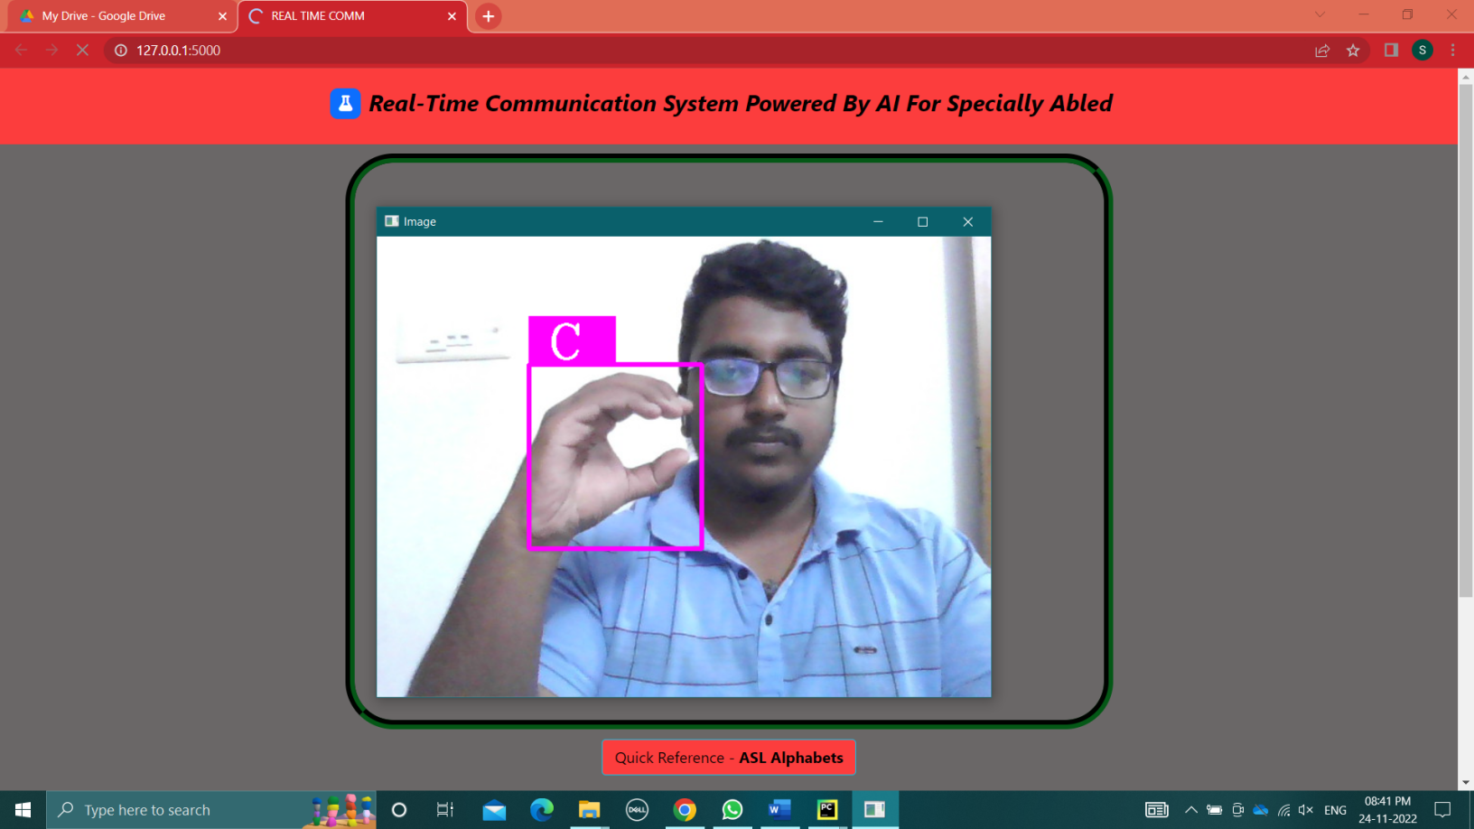

## CHAPTER 10

**ADVANTAGE AND DISADVANTAGE**

ADVANTAGE:

* + - Communication is the key in this society people with disability tends suffer but the proposed system provides a solution to them.
    - Makes the translation of sign language to English easy.
    - It can identify and translate the live and moving images.
    - The proposed system ensures the easy translation of sign language to English.
    - Even the people with lack of sign language can use the proposed system easily.
    - This does not require high-end device to use it.
    - Can be used on almost all operating systems and browses.
    - Does not require prior programming knowledge t use the system
    - The proposed system is user friendly.
    - Makes the life of the person with disability easy.

DISADVANTAGE:

* + - The proposed system is not a two-way translation system.
    - There is chance for wrong translation.
    - Since it is a webpage-based system, it does require internet connectivity which can be inconvenient at times.
    - It would have been convenient if it is application based.

## CHAPTER 11

**CONCLUSION**

Sign language is a useful tool for facilitating communication between deaf and hearing people. Because it allows for two-way communication, the system aims to bridge the communication gap between deaf people and the rest of society. The proposed methodology translates language into English alphabets that are understandable to humans. This system sends hand gestures to the model, who recognizes them and displays the equivalent Alphabet on the screen. Deaf-mute people can use their hands to perform sign language, which will then be converted into alphabets, thanks to this project.

## CHAPTER 12

**FUTURE SCOPE**

In the future to take the project to the next level two way communication system such as sign language to english and english to sign language is beign under the planning phase.The application version of the web page for both ios and android is also in planning process for the future development.Research to improve the accuracy of the system is under progress.

## CHAPTER 13 APPENDIX

SOURCE CODE:

HTML:

<!DOCTYPE html>

<html lang="en">

<head>

<meta charset="utf-8">

<meta name="viewport" content="width=device-width, initial-scale=1.0, shrink-to-fit=no">

<title>REAL TIME COMM</title>

<link rel="stylesheet" href="https://cdn.jsdelivr.net/npm/bootstrap@5.1.3/dist/css/bootstrap.min.css">

<link rel="stylesheet" href="https://use.fontawesome.com/releases/v5.12.0/css/all.css">

<link rel="stylesheet" href="static/Navbar-Centered-Brand.css">

</head>

<body style="background: #6a6767;">

<nav class="navbar navbar-light navbar-expand-md py-3" style="background: #FC3D3D;">

<div class="container">

<div></div><a class="navbar-brand d-flex align-items-left" href="#"><span

class="bs-icon-sm bs-icon-rounded bs-icon-primary d-flex justify-content-left align-items-left me-2 bs-icon"><i

class="fas fa-flask"></i></span><h4 style="color: #030000; font-style: oblique; text-align: left;"><strong> Real-Time Communication

System Powered By AI&nbsp;For Specially Abled</strong></h4></a>

<div></div>

</div>

</nav>

<section>

<div class="d-flex flex-column justify-content-center align-items-center">

<div class="d-flex flex-column justify-content-center align-items-center" id="div-video-feed"

style="width: 800px;height: 600px;margin: 10px;min-height: 480px;min-width: 640px;border-radius: 50px;border: 10px groove #045816 ;">

<img src="{{ url_for('video') }}" style="width: 100%;height: 100%;color: rgb(255,255,255);text-align: center;font-size: 20px;"

alt="Camera Access Not Provided!">

</div>

</div>

<div class="d-flex flex-column justify-content-center align-items-center" style="margin-bottom: 20px;"><button

class="btn btn-info" type="button" data-bs-target="#modal-1" data-bs-toggle="modal"

style=" background: #FC3D3D";>Quick Reference

-<strong> ASL Alphabets</strong></button></div>

</section>

<section>

<div class="modal fade" role="dialog" tabindex="-1" id="modal-1">

<div class="modal-dialog" role="document">

<div class="modal-content">

<div class="modal-header">

<h4 class="modal-title">American Sign Language - Alphabets</h4><button type="button"

class="btn-close" data-bs-dismiss="modal" aria-label="Close"></button>

</div>

<div class="modal-body"><img src='ASL_Alphabet.jpg' height=100% width="450px"></div>

<div class="modal-footer"><button class="btn btn-secondary" type="button"

data-bs-dismiss="modal">Close</button></div>

</div>

</div>

</div>

</section>

<section>

<div class="container">

<div class="accordion text-white" role="tablist" id="accordion-1">

<div class="accordion-item" style="font-style: oblique; background: rgb(33,37,41);">

<h2 class="accordion-header" role="tab"><button class="accordion-button" data-bs-toggle="collapse"

data-bs-target="#accordion-1 .item-1" aria-expanded="true"

aria-controls="accordion-1 .item-1"

style="font-style:inherit; background: #FC3D3D;color: rgb(255,255,255);">About The Project</button></h2>

<div class="accordion-collapse collapse show item-1" role="tabpanel" data-bs-parent="#accordion-1">

<div class="accordion-body">

<p class="mb-0">In our society, we have people with disabilities. The technology is developing day by day but no significant developments are undertaken for the betterment of these people. Communications between deaf-mute and a normal person has always been a challenging task. It is very difficult for mute people to convey their message to normal people. Since normal people are not trained on hand sign language. In emergency times conveying their message is very difficult. The human hand has remained a popular choice to convey information in situations where other forms like speech cannot be used. Voice Conversion System with Hand Gesture Recognition and translation will be very useful to have a proper conversation between a normal person and an impaired person in any language..</p>

</div>

</div>

<div class="accordion-item" style="font-style: oblique; background: rgb(33,37,41);">

<h2 class="accordion-header" role="tab"><button class="accordion-button collapsed"

data-bs-toggle="collapse" data-bs-target="#accordion-1 .item-2" aria-expanded="false"

aria-controls="accordion-1 .item-2"

style="font-style: oblique; background: #FC3D3D;color: rgb(231,241,255);">Developed By</button></h2>

<div class="accordion-collapse collapse item-2" role="tabpanel" data-bs-parent="#accordion-1">

<div class="accordion-body">

<p class="mb-0">Students From Dr.MCET COLLEGE OF ENGINEERING AND TECHNOLOGY<br><br>TEAM ID-- <strong>PNT2022TMID08592</strong><br><br>1. <strong>PRAVEEN KUMAR S</strong> <br>2.

<strong>SAKTHI KAVIN K</strong> <br>3. <strong>LOGESH KUMAR S</strong><br>4. <strong>SHIVAPRIYAN K</strong>

</p>

</div>

</div>

</div>

</div>

</div>

</section>

<script src="https://cdn.jsdelivr.net/npm/bootstrap@5.1.3/dist/js/bootstrap.bundle.min.js"></script>

</body>

</html>

PYTHON:

from flask import Flask, Response, render_template

from camera import Video

import cv2

from keras.models import load_model

from keras.preprocessing import image

import numpy as np

from cvzone.HandTrackingModule import HandDetector

from cvzone.ClassificationModule import Classifier

import math

app = Flask(__name__)

camera = cv2.VideoCapture(0)

detector = HandDetector(maxHands=1)

classifier = Classifier('E:/ibm project/prj10/keras_model.h5', 'E:/ibm project/prj10/labels.txt')

offset = 20

imgSize = 300

#folder = "Data/C"

counter = 0

labels = ["A", "B", "C"]

@app.route('/')

def index():

return render_template('index.html')

def gen():

while True:

success, img = camera.read()

imgOutput = img.copy()

hands, img = detector.findHands(img)

if hands:

hand = hands[0]

x, y, w, h = hand['bbox']

imgWhite = np.ones((imgSize, imgSize, 3), np.uint8) * 255

imgCrop = img[y - offset:y + h + offset, x - offset:x + w + offset]

imgCropShape = imgCrop.shape

aspectRatio = h / w

if aspectRatio > 1:

k = imgSize / h

wCal = math.ceil(k * w)

imgResize = cv2.resize(imgCrop, (wCal, imgSize))

imgResizeShape = imgResize.shape

wGap = math.ceil((imgSize - wCal) / 2)

imgWhite[:, wGap:wCal + wGap] = imgResize

prediction, index = classifier.getPrediction(imgWhite, draw=False)

print(prediction, index)

else:

k = imgSize / w

hCal = math.ceil(k * h)

imgResize = cv2.resize(imgCrop, (imgSize, hCal))

imgResizeShape = imgResize.shape

hGap = math.ceil((imgSize - hCal) / 2)

imgWhite[hGap:hCal + hGap, :] = imgResize

prediction, index = classifier.getPrediction(imgWhite, draw=False)

cv2.rectangle(imgOutput, (x - offset, y - offset - 50),

(x - offset + 90, y - offset - 50 + 50), (255, 0, 255), cv2.FILLED)

cv2.putText(imgOutput, labels[index], (x, y - 26), cv2.FONT_HERSHEY_COMPLEX, 1.7, (255, 255, 255), 2)

cv2.rectangle(imgOutput, (x - offset, y - offset),

(x + w + offset, y + h + offset), (255, 0, 255), 4)

# cv2.imshow("ImageCrop", imgCrop)

# cv2.imshow("ImageWhite", imgWhite)

# cv2.imshow("Image", imgOutput)

k = cv2.waitKey(1)

if k == ord('q'):

break

camera.release()

cv2.destroyAllWindows()

yield (b'--frame\r\n'

b'Content-Type: image/jpeg\r\n\r\n' + imgOutput + b'\r\n')

@app.route('/video')

def video():

# video = Video()

return Response(gen(), mimetype='multipart/x-mixed-replace; boundary=frame')

if __name__ == '__main__':

app.run()

TRAINNING CODE:

# Importing Libraries

from tensorflow.keras.preprocessing.image import ImageDataGenerator # Image Augmentation

train_datagen = ImageDataGenerator(rescale = 1./255, shear_range = 0.2, zoom_range = 0.2, horizontal_flip = True)

test_datagen = ImageDataGenerator(rescale = 1./255) # Loading train and test set

X_train = train_datagen.flow_from_directory(r"E:\ibm project\Real time communication system\Dataset\training_set", target_size = (64, 64), batch_size = 32, class_mode

= 'categorical')

X_test = test_datagen.flow_from_directory(r"E:\ibm project\Real time communication system\Dataset\training_set", target_size = (64, 64), batch_size = 32, class_mode

= 'categorical')

# checking indices X_train.class_indices # Importing Libraries

from tensorflow.keras.models import Sequential from tensorflow.keras.layers import Dense

from tensorflow.keras.layers import Convolution2D, MaxPooling2D, Flatten # Initializing the Model

model = Sequential()

# Adding Convolution Layer

model.add(Convolution2D((32), (3,3), input_shape = (64, 64, 3), activation = 'relu')) # Adding Pooling Layer

model.add(MaxPooling2D(pool_size = (2, 2))) # Adding Flatten Layer

model.add(Flatten())

# Adding Hidden Layer

model.add(Dense(units = 512, kernel_initializer = 'random_uniform', activation = 'relu')) # Adding Output Layer

model.add(Dense(units = 9, kernel_initializer = 'random_uniform', activation = 'softmax'))

# Compile the model

model.compile(loss = 'categorical_crossentropy', optimizer = 'adam', metrics = ['accuracy'])

# Fiiting the model

model.fit_generator(X_train, steps_per_epoch = 24, epochs = 10, validation_data = X_test, validation_steps = 40)

# Saving the model model.save('aslpng1.h5') TESTING CODE:

# Importing Libarries

from tensorflow.keras.models import load_model from tensorflow.keras.preprocessing import image

import numpy as np import cv2

# loading model

model = load_model('realtime.h5') from skimage.transform import resize def detect(frame):

img = resize(frame, (64, 64, 3))

img = np.expand_dims(img, axis = 0) if np.max(img) > 1:

img = img/255.0

prediction = model.predict(img) print(prediction)

return prediction

frame = cv2.imread(r"E:\ibm project\Real time communication system\Dataset\test_set\A\16.png")

data = detect(frame)

index = ['A','B','C','D','E','F','G','H','I']

index[np.argmax(data)] # Importing Libraries import cv2

import numpy as np

from tensorflow.keras.models import load_model from tensorflow.keras.preprocessing import image # Loading Model

model = load_model("real time.h5")

video = cv2.VideoCapture(0)

index = ['A','B','C','D','E','F','G','H','I']

while True:

success, frame = video.read() cv2.imwrite('frame.jpg', frame)

img = image.load_img('frame.jpg', target_size = (64, 64))

x = image.img_to_array(img)

x = cv2.cvtColor(x, cv2.COLOR_BGR2HSV) a = x.array_to_img(x)

cv2.imshow("")

x = np.expand_dims(x, axis = 0)

pred = np.argmax(model.predict(x), axis = 1) y = pred[0]

copy = frame.copy()

cv2.rectangle(copy, (320, 100), (620, 400), (255, 0, 0), 5)

cv2.putText(frame, "The Predicted Alphabet : " + str(index[y]), (100, 100), cv2.FONT_HERSHEY_SIMPLEX, 1, (0, 0, 0), 4)

cv2.imshow('frame', frame)

if cv2.waitKey(1) & 0xFF == ord('q'): break

video.release() cv2.destroyAllWindows()

## GITHUB LINK:

## <https://github.com/IBM-EPBL/IBM-Project-2066-1658425644>

## DEMO LINK:

https://drive.google.com/file/d/1yj986G_ZND1POuynnNlDB6jH9f0COU_y/view?usp=share_link